

Team ID : LTVIP2025TMID47877

Project By :

Eli Rohith Sri Ganesh

# 1. INTRODUCTION

1.1 Project Overview

Economic freedom plays a cri cal role in determining a country's prosperity, compe veness, and the overall well-being of its ci zens. However, while numerous datasets and reports exist, there is a gap in interac ve and compara ve tools that make this informa on accessible and ac onable for diverse stakeholders.

This project aims to analyse and visualize the Index of Economic Freedom across mul ple countries to provide insights into the rela onship between economic policies and na onal prosperity. Using sta s cal analysis, data visualiza on techniques, and real- me filtering capabili es, the pla orm enables policymakers, researchers, investors, and the general public to explore key economic indicators in an intui ve and meaningful way.

The solu on integrates data inges on, processing, and visualiza on in a modular architecture, offering features like global freedom heatmaps, year-wise trends, top/bo om ranked countries, and correla on analysis with other socio-economic metrics like GDP and unemployment rates. This project bridges the gap between raw data and informed decisionmaking through a transparent, scalable, and user-centric approach.

1.2 Purpose

The purpose of this project is to create an accessible, data-driven pla orm that enables the analysis and visualiza on of the Index of Economic Freedom across different countries and me periods. This ini a ve seeks to empower policymakers, researchers, and investors by

providing them with ac onable insights into how economic freedom influences prosperity, governance, and development. By transforming complex datasets into interac ve dashboards and compara ve tools, the project promotes informed decision-making, encourages transparency in economic policies, and supports academic and ins tu onal research. Ul mately, the solu on aspires to highlight global economic pa erns and guide strategic reforms aimed at enhancing economic liberty and growth.

# 2. IDEATION PHASE

2.1 Problem Statement

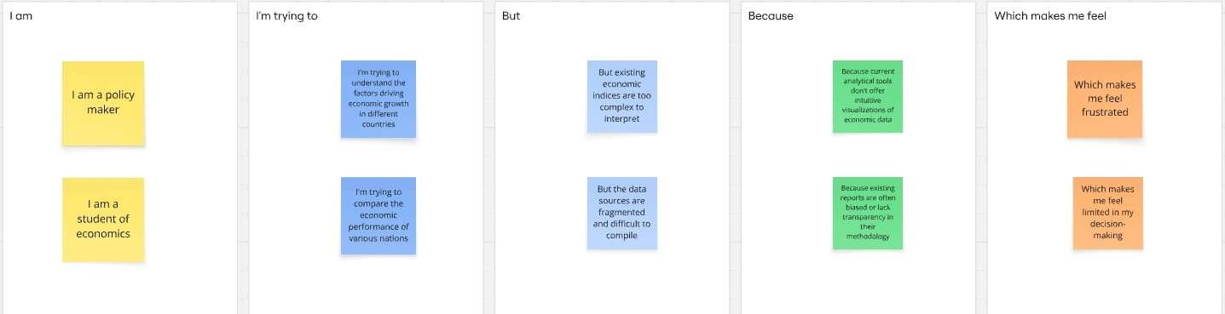

|  |  |  |  |  |  |
| --- | --- | --- | --- | --- | --- |
| Problem  Statement  (PS) | I am  (Customer  ) | I’m trying to | But | Because | Which makes me feel |
| PS-1 | a  policymak  er | understand the drivers of economic prosperity in  different  na ons to formulate effec ve policies. | exis ng economic  indices are o en too complex, lack mely updates. | there's a need  for a  comprehensive, easily diges ble, and regularly updated index that integrates various dimensions of economic freedom. | frustrated and uncertain about the op mal policy choices. |
| PS-2 | an economic researcher | iden fy clear correla ons between economic freedom and socioeconomic outcomes for academic analysis. | current data sources are  fragmented  ,  inconsistent  , and difficult to  compare across different  countries  and me periods. | there isn't a standardized, reliable, and easily accessible  dataset that combines diverse indicators of economic freedom with  relevant outcome variables. | overwhelmed by data collec on and analysis, and limited in drawing robust conclusions. |

2.2 Empathy Map Canvas

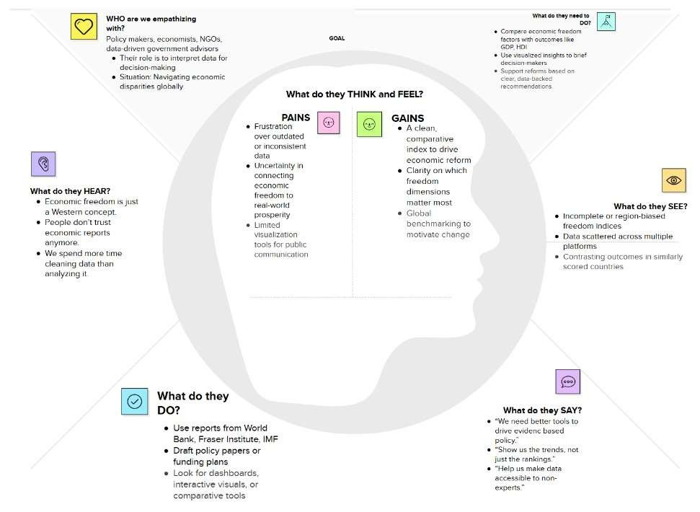

2.3 Brainstorming

Step-1: Team Gathering, Collabora on and Select the Problem Statement

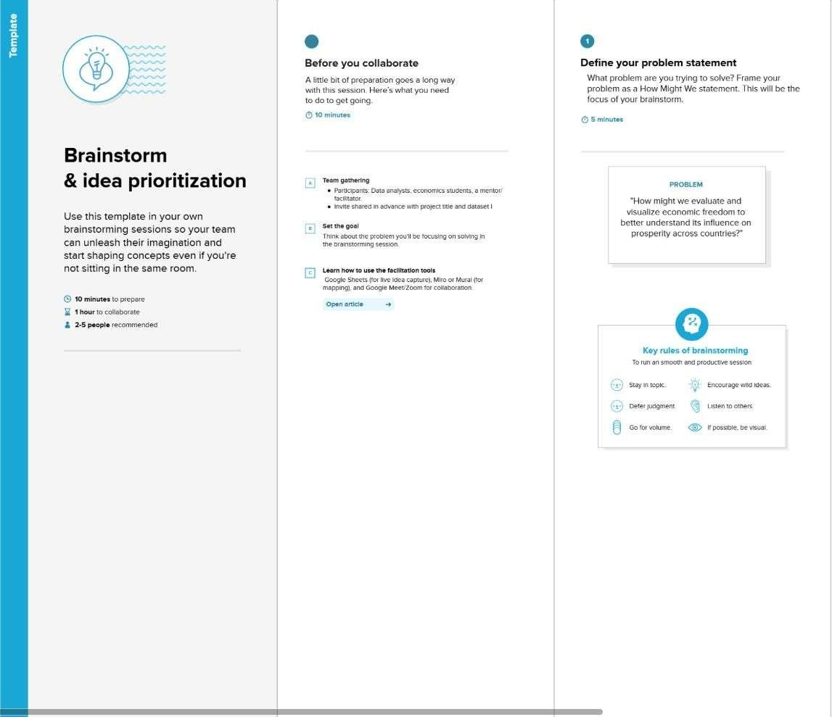

Step-2: Brainstorm, Idea Lis ng and Grouping

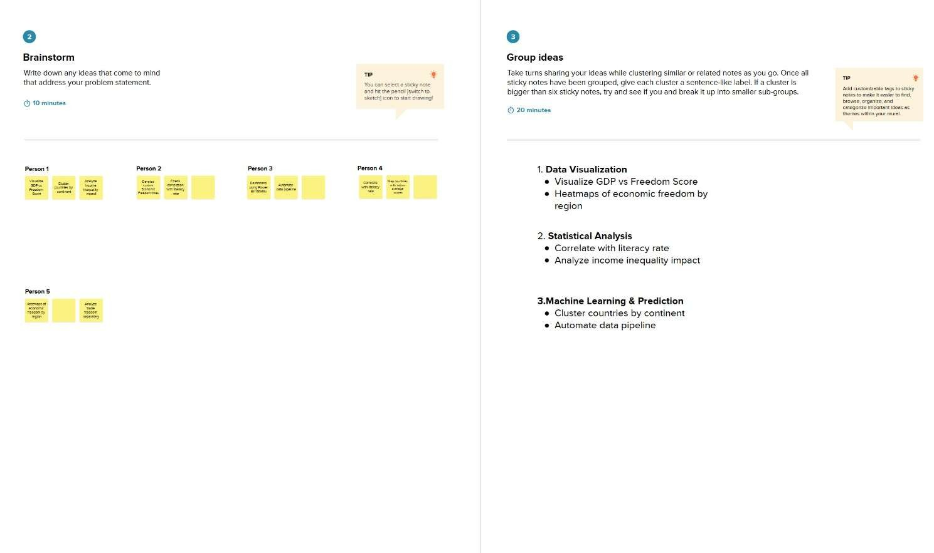

Step-3: Idea Priori za on

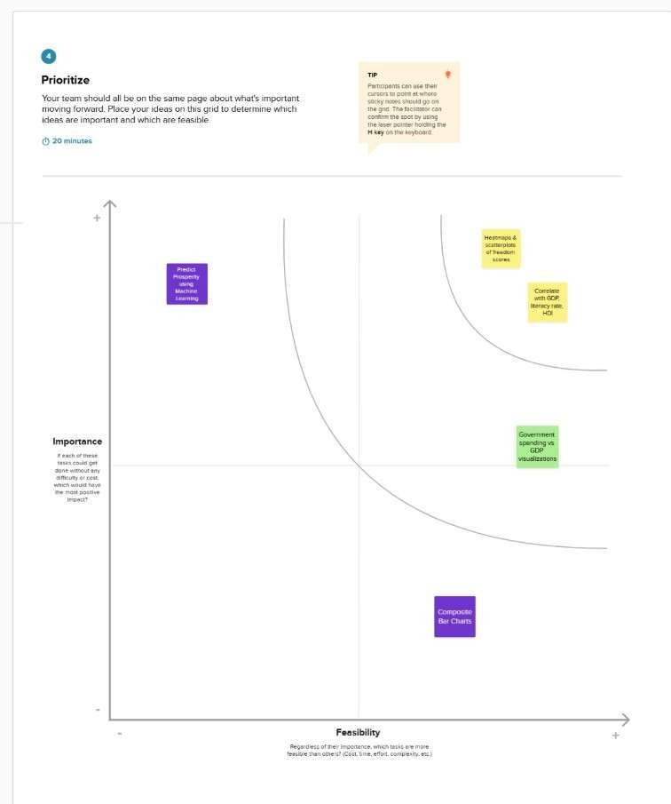

# 3. REQUIREMENT ANALYSIS

3.1 Customer Journey map

|  |  |  |  |  |
| --- | --- | --- | --- | --- |
| Stage | Ac ons | Thoughts | Touchpoints | Pain Points |
| Discovery | Learns about the pla orm via seminar,  academic circles, or reports. | “Is there a tool that shows how economic freedom affects prosperity?” | University portals, policy newsle ers,  GitHub, search engines | Lack of accessible and  reliable  visualiza on tools |
| Access | Visits the  pla orm and browses the landing page. | “Is this data recent? Can I trust the source?” | Web interface, data source  links (e.g.,  Heritage  Founda on) | Trust in data, understanding source  credibility |
| Interac on | Filters data by year/country, views heatmaps and rankings. | “I want to compare my country with others or across years.” | Dashboard,  filtering tools, charts,  dropdown selectors | Trust in data, understanding source  credibility |

3.2 Solu on Requirement

Func onal Requirements:

Following are the func onal requirements of the proposed solu on.

|  |  |  |
| --- | --- | --- |
| FR No. | Func onal Requirement (Epic) | Sub Requirement (Story / Sub-Task) |
| FR-1 | User Registra on | Registra on through Form  Registra on through Gmail  Registra on through LinkedIn |
| FR-2 | User Confirma on | Confirma on via Email  Confirma on via OTP |
| FR-3 | Data Inges on & Management | Upload Dataset (e.g., CSV, Excel, from external APIs)  Data Valida on and Cleaning  Data Storage and Organiza on (e.g., database) |
| FR-4 | Economic Freedom Index  Calcula on | Define and Configure Index Components  Apply Weigh ng Schemes (configurable by user/admin) Calculate Composite Index Scores for countries/regions |
| FR-5 | Data Analysis & Visualiza on | Generate Interac ve Charts (e.g., Bar, Line, Sca er, Bubble)  Create Geographic Visualiza ons (e.g., Choropleth Maps)  Provide Trend Analysis over Time  Enable Comparison between Countries/Regions Display Correla on Matrices between indicators |
| FR-6 | Repor ng & Export | Generate Customizable Reports (e.g., PDF, HTML)  Export Raw and Processed Data (e.g., CSV, Excel)  Export Visualiza ons (e.g., Image formats like PNG, JPEG) |
| FR-7 | User Authen ca on &  Authoriza on | User Login/Logout  Role-based Access Control (e.g., Admin, Analyst, Viewer) |
| FR-8 | Search & Filter Func onality | Search by Country Name, Year, Index Component  Filter Data by various criteria (e.g., region, income level) |

Non-func onal Requirements:

Following are the non-func onal requirements of the proposed solu on.

|  |  |  |
| --- | --- | --- |
| FR No. | Non-Func onal Requirement | Descrip on |
| NFR-1 | Usability | The system should have an intui ve and userfriendly interface, allowing users to easily navigate, interact with data, and interpret results without extensive training. |
| NFR-2 | Security | The system must protect sensi ve user data (if any) and ensure the integrity and confiden ality of the economic data. This includes secure authen ca on, authoriza on, and protec on against unauthorized access or data breaches. |
| NFR-3 | Reliability | The system should consistently perform its func ons accurately and without significant errors. Data calcula ons, visualiza ons, and report genera on should be reliable and repeatable. |
| NFR-4 | Performance | The system should respond quickly to user requests, especially during data processing, index calcula on, and visualiza on genera on, even with large datasets. Data loading and rendering mes should be minimal. |
| NFR-5 | Availability | The system should be accessible to authorized users whenever needed, with minimal down me. This includes considera ons for server up me, data accessibility, and disaster recovery. |
| NFR-6 | Scalability | The system should be able to handle an increasing amount of data (e.g., more countries, more years, new indicators), a growing number of concurrent users, and addi onal features without significant degrada on in performance. |
| NFR-7 | Maintainability | The system's codebase and architecture should be well-documented, modular, and easy to modify or extend to accommodate future enhancements or bug fixes. |
| NFR-8 | Data Accuracy | The system must ensure the highest level of accuracy for all ingested data, calcula ons, and visualiza ons to reflect reliable economic insights. |

3.3 Data Flow Diagram User Stories

|  |  |  |  |  |  |  |
| --- | --- | --- | --- | --- | --- | --- |
| User Type | Function  al  Requirem  ent (Epic) | User  Story  Numb  er | User Story / Task | Acceptance  criteria | Priorit y | Releas  e |
| Policymaker | Data  Analysis & Visualizati on | USN-1 | As a Policymaker, I want to view a world map showing economic freedom scores by country, so that I can quickly identify regions with high or low economic prosperity and potential policy impact areas. | The map  correctly  displays economic freedom scores, and I can identify regions visually. | High | Sprint-  1 |
| Economic Researcher | Data  Analysis & Visualizati on | USN-2 | As an Economic  Researcher, I want to filter economic data by specific years and countries, so that I can conduct in-depth  analysis on historical trends and compare performance across different nations. | I can apply filters for years and countries, and the data displayed updates accordingly. | High | Sprint-  1 |
| Investor | Data  Analysis & Visualizati on | USN-3 | As an Investor, I want to see the top 40 and least ranked countries based on their economic index, so that I can identify potential investment opportunities or risks in various markets. | The list of top and least ranked countries is accurate and easily accessible. | High | Sprint-  1 |
| User | Data  Ingestion  &  Managem  ent | USN-4 | As a User, I want to upload new economic datasets  (e.g., CSV, Excel), so that I can incorporate the latest information into the analysis and update the index. | I can successfully upload a dataset, and its data is visible in the system. | Mediu m | Sprint-  2 |
| Economic Researcher | Data  Analysis & Visualizati on | USN-5 | As an Economic  Researcher, I want to view correlations between  economic freedom and indicators like unemployment rate and GDP growth, so that I can understand the multifaceted impacts of economic policies. | The system generates a report with selected  criteria, and I can download it in my desired format (e.g., PDF). | High | Sprint-  2 |
| User | Reporting & Export | USN-6 | As a User, I want to export visualizations (e.g., charts, maps) as image files, so | I can export displayed visualizations | Mediu m | Sprint-  1 |
| User Type | Function  al  Requirem  ent (Epic) | User  Story  Numb  er | User Story / Task | Acceptance  criteria | Priorit y | Releas  e |
|  |  |  | that I can easily include them in presentations or reports. | as image files (e.g., PNG, JPEG). |  |  |
| Administrat  or | User  Managem ent & Authorizati on | USN-7 | As an Administrator, I want to manage user accounts and roles, so that I can access levels to sensitive data and functionalities. | I can add, edit, and remove users, and assign. | High | Sprint-  1 |

# 4. PROJECT DESIGN

4.1 Problem Solu on Fit

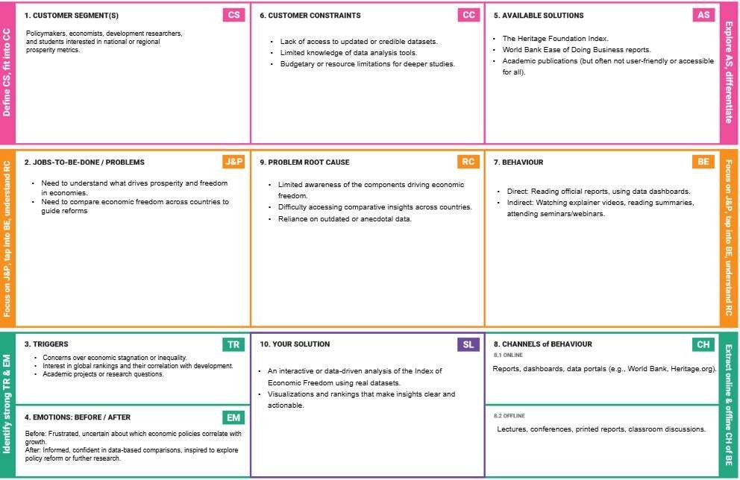

4.2 Proposed Solu on

Proposed Solu on Template:

Project team shall fill the following informa on in the proposed solu on template

|  |  |  |
| --- | --- | --- |
| S.No. | Parameter | Descrip on |
| 1. | Problem Statement (Problem to be solved) | Despite the availability of macroeconomic data, policymakers and researchers lack a clear, accessible method to evaluate how economic freedom correlates with prosperity. |
| 2. | Idea / Solu on descrip on | The project analyses the Economic Freedom Index using data visualiza on and compara ve analysis tools. It offers clear dashboards, insights, and recommenda ons across countries |
| 3. | Novelty / Uniqueness | While reports exist, this solu on provides an interac ve, compara ve, and visually rich pla orm combining mul ple data dimensions useful for academia and policy |
| 4. | Social Impact / Customer Sa sfac on | Informed ci zens, be er policy decisions, and transparency in economic governance. This tool helps iden fy reforms needed to enhance freedom and economic performance. |
| 5. | Business Model (Revenue Model) | Can be offered as a freemium tool for students/researchers, with advanced insights and country reports available via subscrip on for ins tu ons, think tanks, or NGOs. |
| 6. | Scalability of the Solu on | Can be extended to include regional/state-level indices, me-series trends, or integra on with other indicators (e.g., Human Development Index, Corrup on Percep on Index). |

4.3 Solu on Architecture

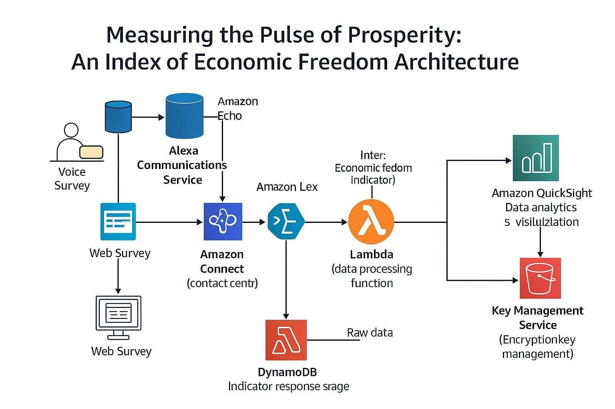

# 5. PROJECT PLANNING & SCHEDULING

5.1 Project Planning

|  |  |  |  |  |  |
| --- | --- | --- | --- | --- | --- |
| Sprint | Functional Requirement  (Epic) | User  Story  Number | User Story / Task | Story Points | Priority |
| Sprint-1 | Data Analysis  &  Visualization | USN-1 | As a Policymaker, I want to view a world map showing economic freedom scores by country, so that I can quickly identify regions with high or low economic prosperity and potential policy impact areas. | 2 | High |
| Sprint-1 | Data Analysis  &  Visualization | USN-2 | As an Economic Researcher, I want to filter economic data by specific years and countries, so that I can conduct in-depth analysis on historical trends and compare performance across different nations. | 2 | High |
| Sprint-1 | Data Analysis  &  Visualization | USN-3 | As an Investor, I want to see the top 40 and least ranked countries based on their economic index, so  that I can identify potential investment opportunities or risks in various markets. | 2 | High |
| Sprint-2 | Data  Ingestion &  Management | USN-4 | As a User, I want to upload new economic datasets (e.g., CSV, Excel), so that I can incorporate | 3 | Medium |
|  |  |  | the latest information into the analysis and update the index |  |  |
| Sprint-2 | Data Analysis  &  Visualization | USN-5 | As an Economic Researcher, I want to view correlations between economic freedom and indicators like unemployment rate and GDP growth, so that I can understand the multifaceted impacts of economic policies. | 4 | High |
| Sprint-3 | Reporting & Export | USN-6 | As a User, I want to export visualizations (e.g., charts, maps) as image files, so that I can easily include them in presentations or reports. | 4 | Medium |
| Sprint-3 | User Management  &  Authorization | USN-7 | As an Administrator, I want to manage user accounts and roles, so that I can access levels to sensitive data and functionalities. | 3 | High |

Project Tracker, Velocity & Burndown Chart:

|  |  |  |  |  |  |  |
| --- | --- | --- | --- | --- | --- | --- |
| Sprint | Total Story Points | Duration | Sprint Start Date | Sprint End Date  (Planned) | Story Points  Completed  (as on  Planned End  Date) | Sprint Release Date (Actual) |
| Sprint-1 | 6 | 5 Days | 16 June 2025 | 21June 2025 | 6 | 21 June 2025 |
| Sprint-2 | 7 | 5 Days | 21June 2025 | 25 June 2025 | 7 | 25 June 2025 |
| Sprint-3 | 7 | 5 Days | 25 June 2025 | 30 June 2025 |  |  |

Velocity:

Imagine we have a 10-day sprint duration, and the velocity of the team is 20 (points per sprint). Let’s calculate the team’s average velocity (AV) per iteration unit (story points per day) AV = sprint dura on/velocity =15/10=1.5

Burndown Chart:

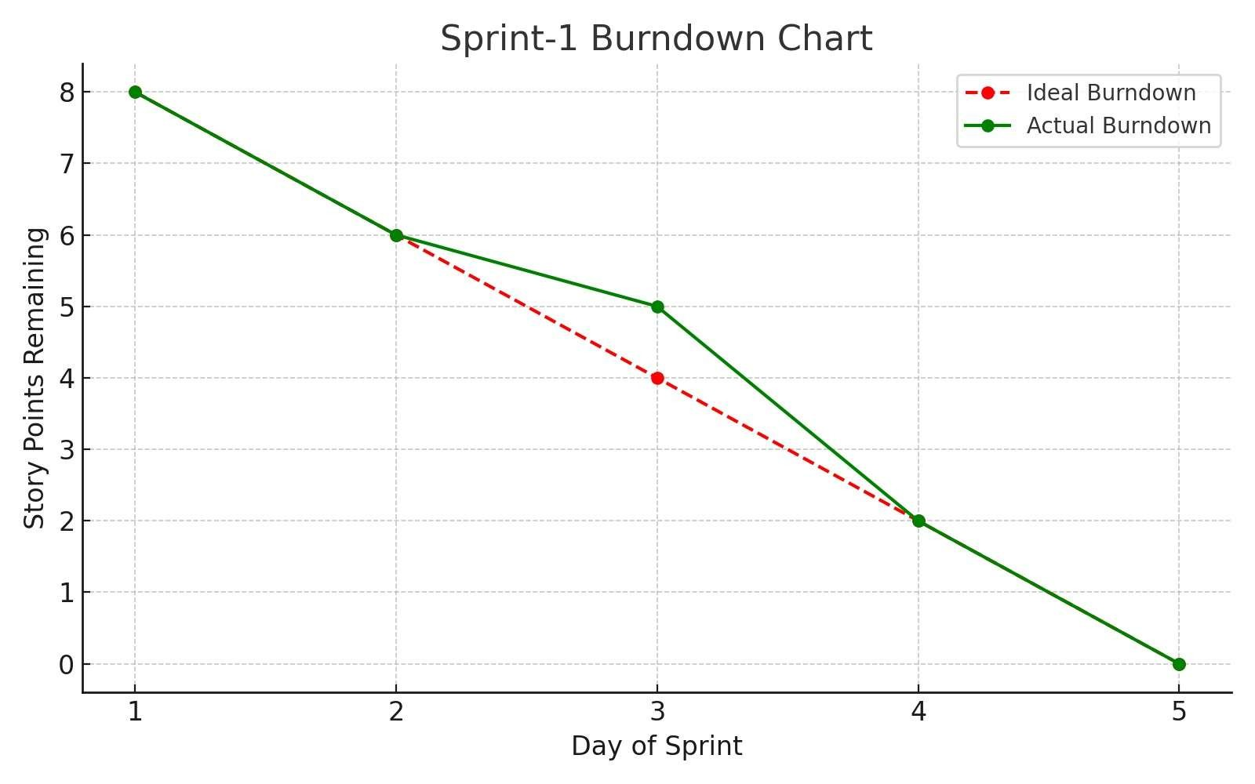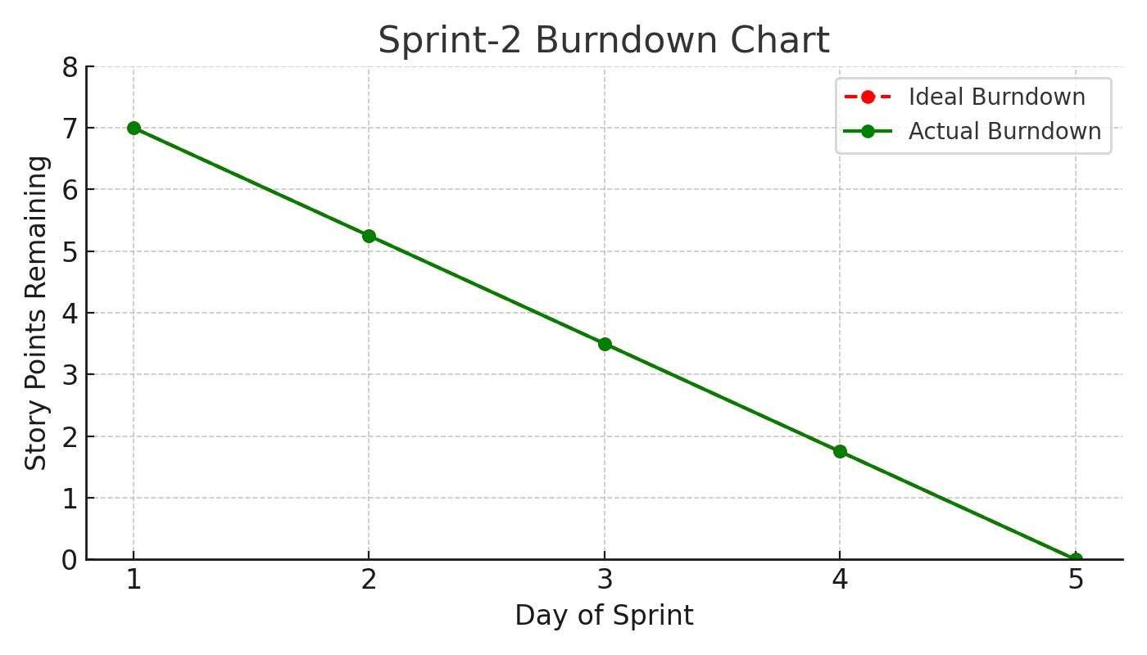

## 6. FUNCTIONAL AND PERFORMANCE TESTING

6.1 Performance Tes ng

Model Performance Tes ng:

Project team shall fill the following informa on in model performance tes ng template.

|  |  |  |
| --- | --- | --- |
| S.No. | Parameter | Screenshot / Values |
| 1. | Data Rendered | The dashboard renders comprehensive country-level economic data including:   * Economic Score/Index * Country ID and Country Name * 5-Year GDP Growth Rate * Business Freedom, Corporate Tax Rate (%), FDI Inflow   (Millions), Financial Freedom, Fiscal Health, GDP (Billions),  GDP Growth Rate (%), GDP per Capita (PPP), Government  Integrity, Government Expenditure (%) of GDP, Government Spending, Income Tax Rate (%), Infla on (%), Index of Popula on, Unemployment (%).  -The data appears to cover mul ple years, showing trends and comparisons across a wide range of countries |

|  |  |  |
| --- | --- | --- |
| 2. | Data Preprocessing | Preprocessing likely involved:   * Data Cleaning: Handling missing values, correc ng inconsistencies, and standardizing country names. * Data Transforma on: Aggrega ng data to specific years or regions, poten ally calcula ng the composite   Economic Freedom Index from its cons tuent components.   * Geographic Data Prepara on: Ensuring country names are recognized by Tableau for mapping. * Feature Engineering: Crea ng calculated fields such as "5 Year GDP Growth Rate" or specific "Economic Score" components if not directly present in the raw data. |
| 3. | U liza on of Filters | The dashboard extensively uses filters and interac ve elements:   * Country Name Filter: Allows users to select specific countries for focused analysis. * Measures Filter: To select different economic indicators (e.g., Infla on, Unemployment, GDP) for visualiza on and correla on. * Year Slider/Filter: To change the year for which the data is displayed on the map and other charts. * Interac ve Map Selec on: Clicking on countries on   the map appears to filter other related views |

|  |  |  |
| --- | --- | --- |
| 4. | Calcula on fields Used | Based on the metrics and visualiza ons, the following calculated fields are likely used:   * Economic Score/Index: A composite score derived from various sub-indicators of economic freedom. * 5 Year GDP Growth Rate: Likely a calcula on based on GDP values over a five-year period. * Rankings: Calculated fields to determine and display the "Top 40 countries rank of Economy" and "Least ranked countries of economic index." * Region Groupings: Possibly a calculated field to group countries into broader regions for high-level analysis. |
| 5. | Dashboard design | No of Visualiza ons / Graphs –  The primary dashboard ("Dashboard 1" / "Global Rankings & Financial Freedom Impact Dashboard") contains at least 5 dis nct visualiza ons/sec ons |
|  |  | * Choropleth Map (e.g., "Visualizing Economic Freedom and Instability Around the World") * Correla on Chart (e.g., "Correla on of Countries Based on Infla on & Unemployment") * Horizontal Bar Chart (e.g., "Index of Popula on") * "Insights Overview" Text Box * "Top 40 Countries rank of Economy" bar/map chart   -"Countries Less Than 25 of Economy Index" (poten ally a tree map or similar chart) |
| 6 | Story Design | No of Visualiza ons / Graphs –  The "Story" sec on ("Journey Through the 2002 Global Economy") explicitly shows 5 story points/pages, each poten ally containing one or more visualiza ons:   * Story Point 1: World Map of Economic Score. * Story Point 2: Top 40 Countries Rank. * Story Point 3: Least Ranked Countries. * Story Point 4: Correla on of Countries Based on Infla on & Unemployment. * Story Point 5: Index of Popula on. * Story Point 6: Financial Freedom of Countries. * Story Point 7: Index of 5 yrs GDP Rate. |

## 7. RESULTS

7.1 Output Screenshots

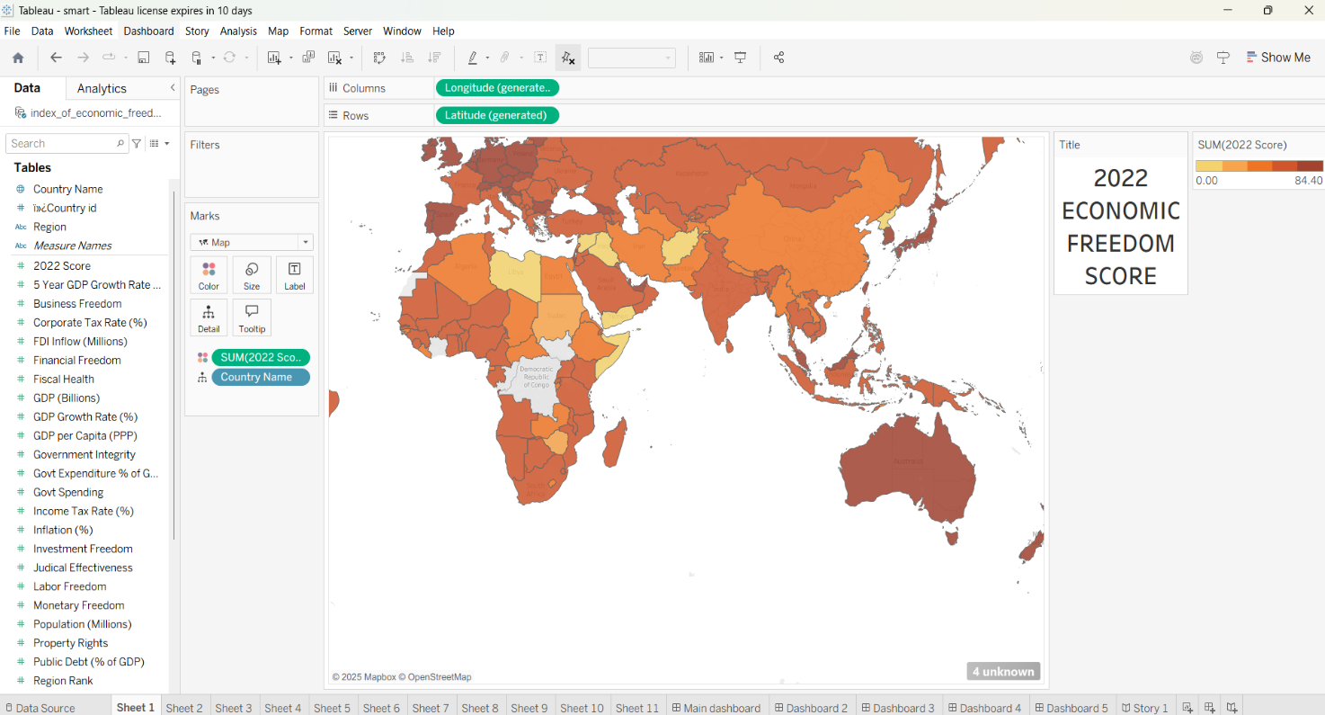

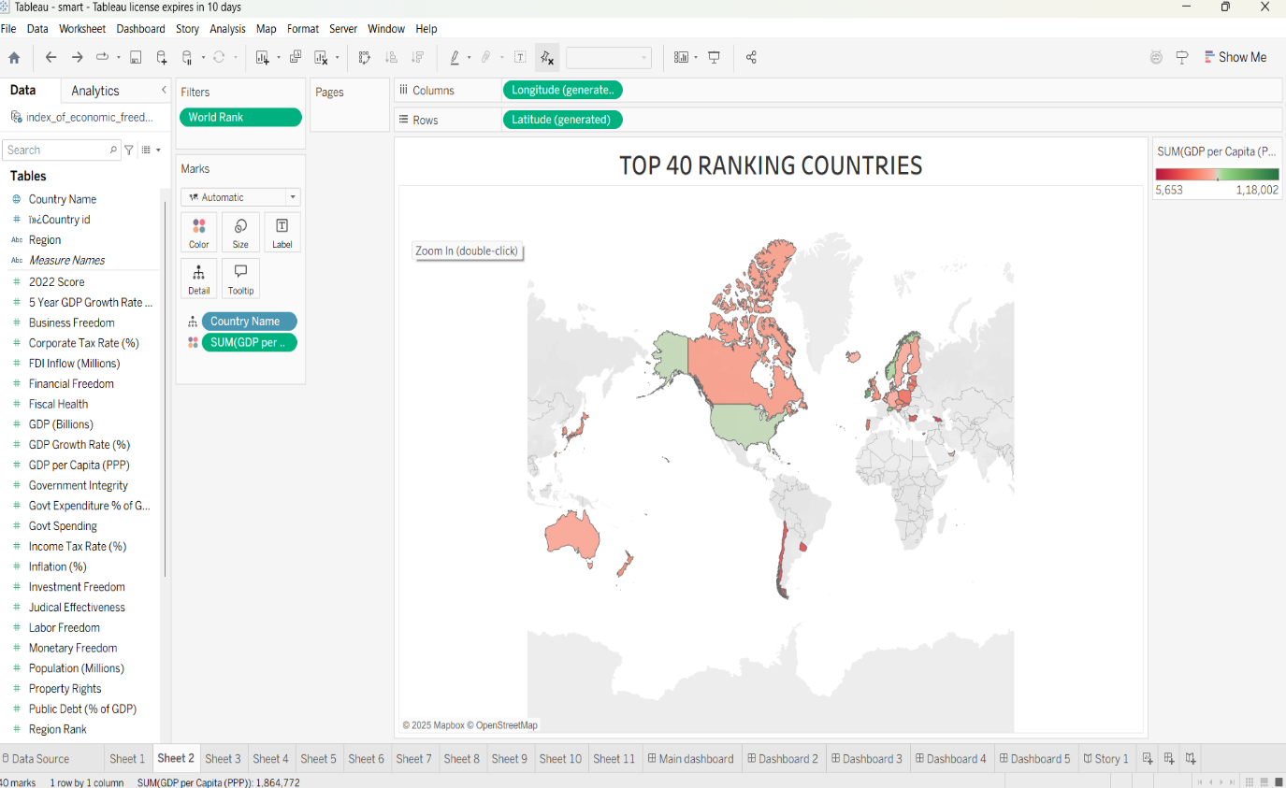

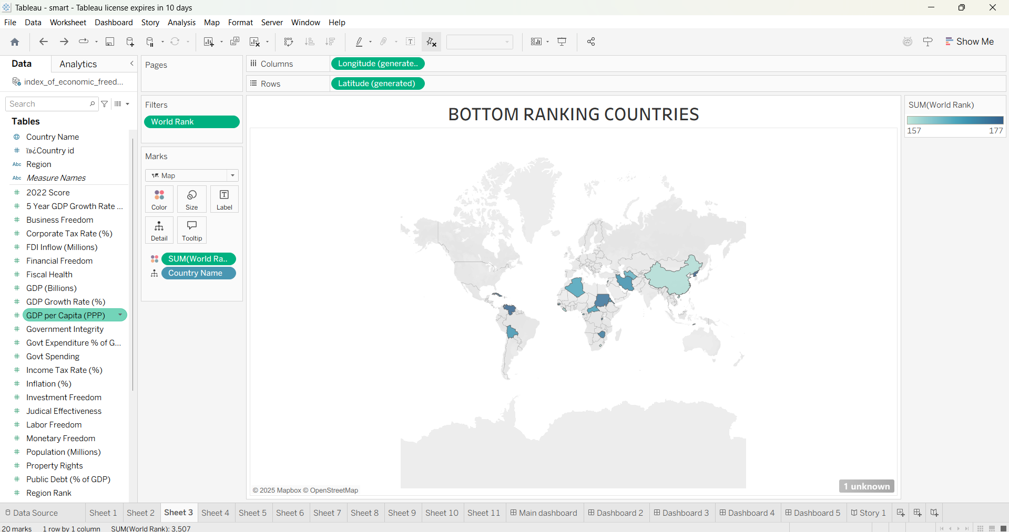

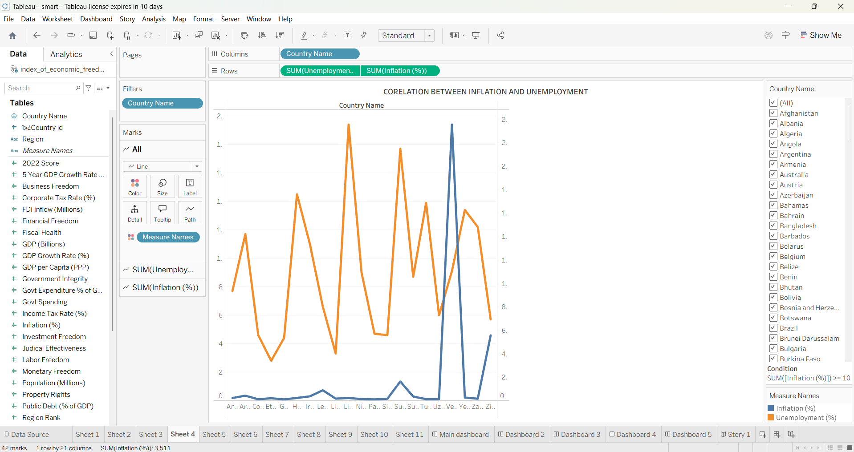

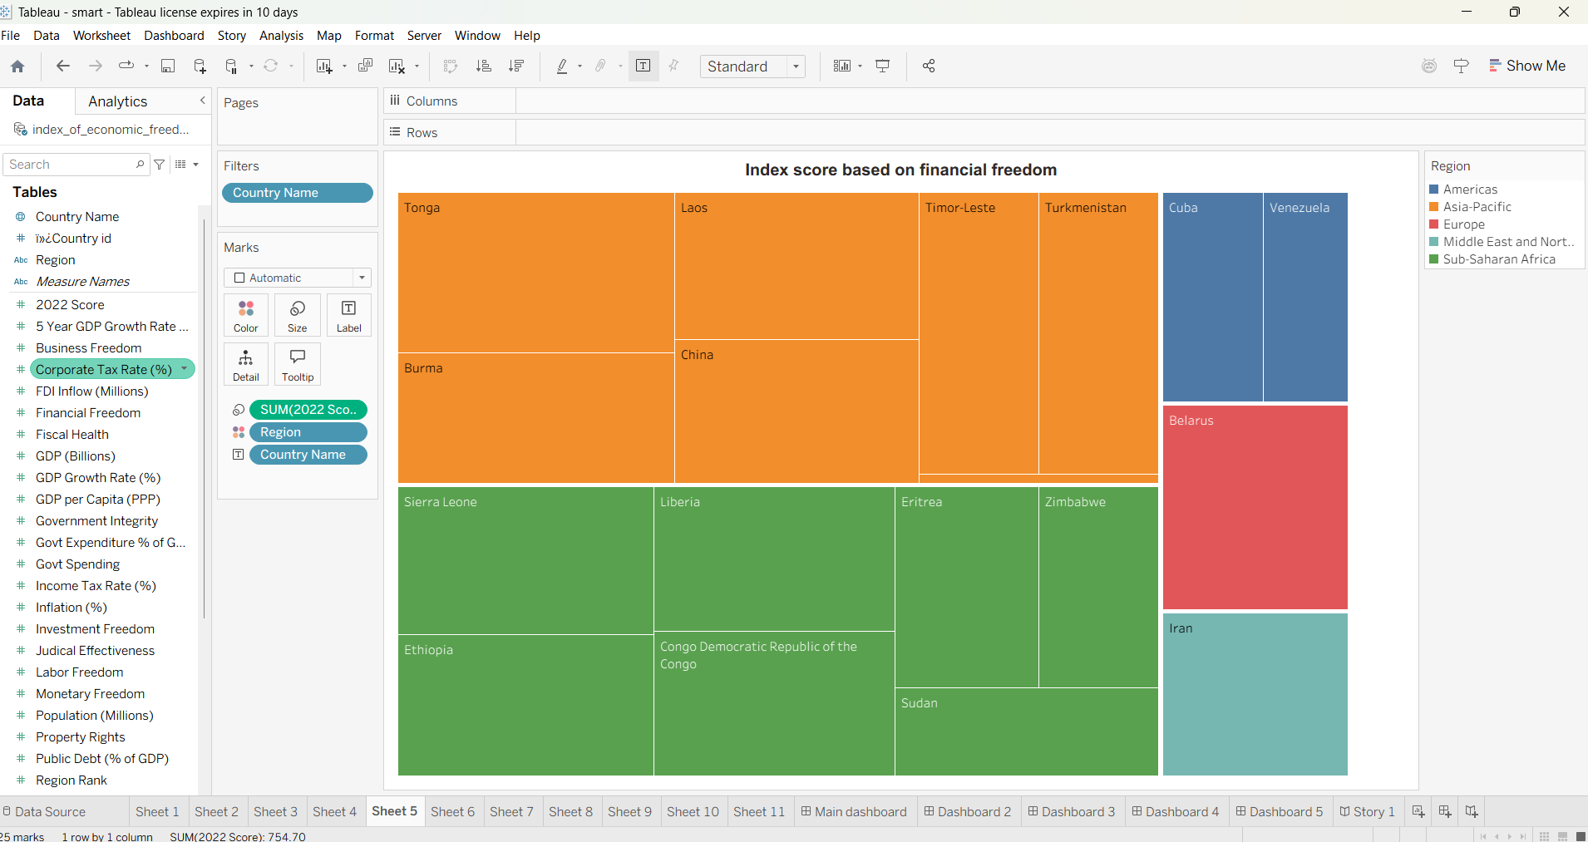

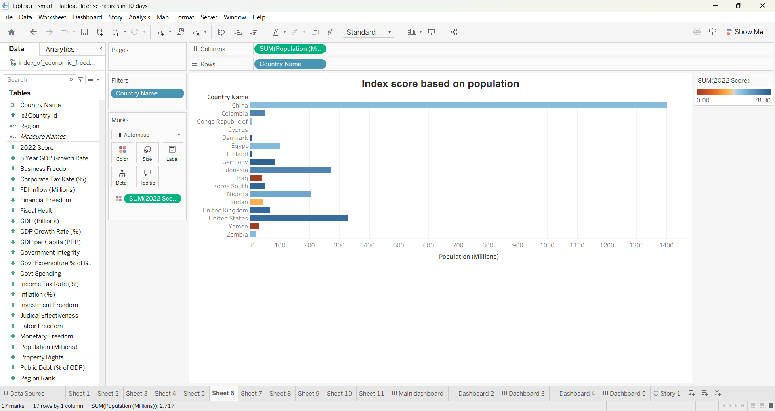

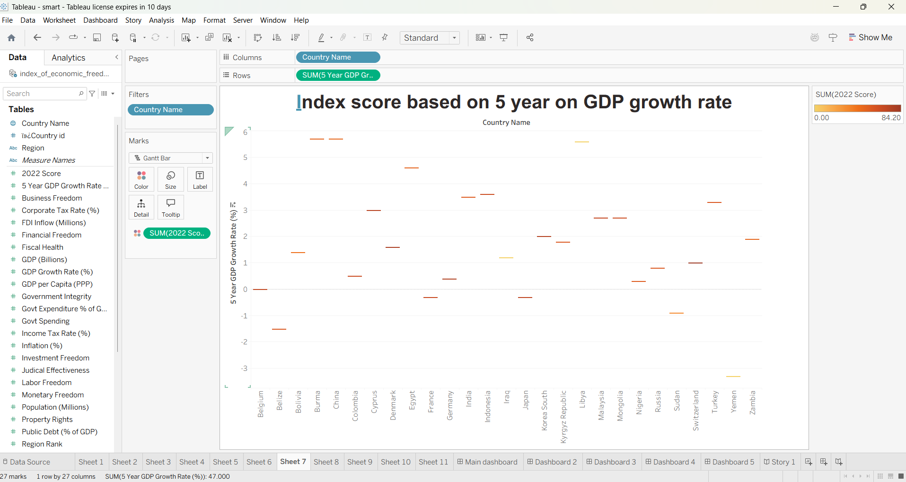

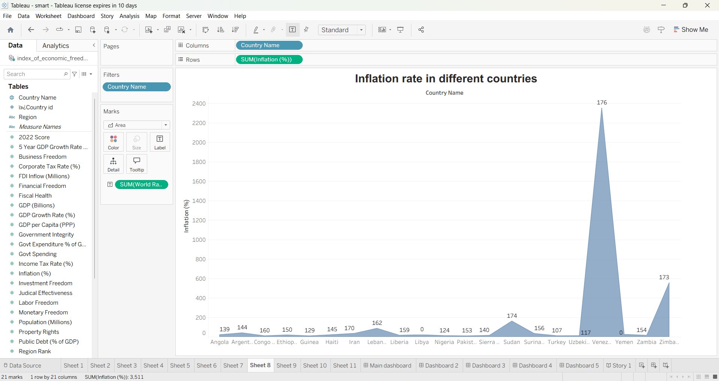

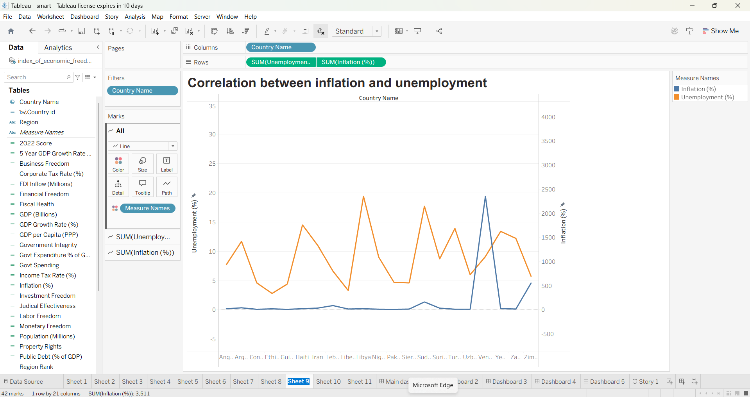

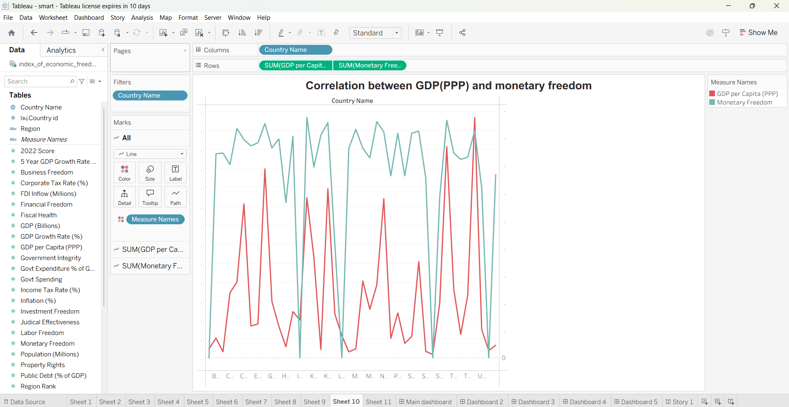

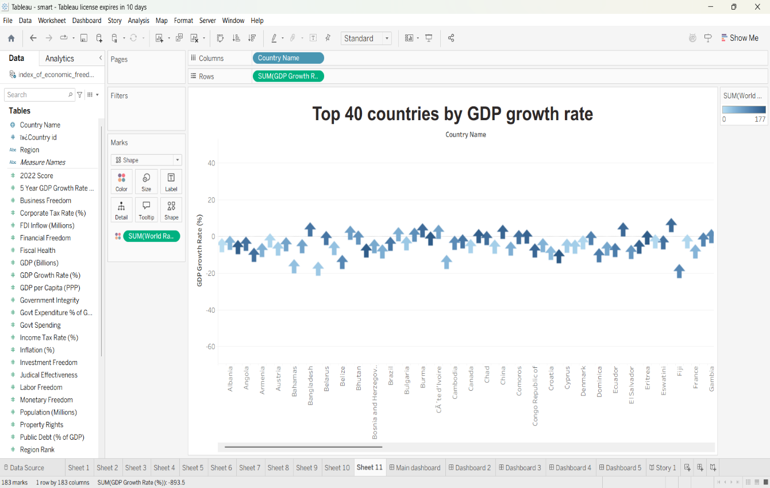

## 

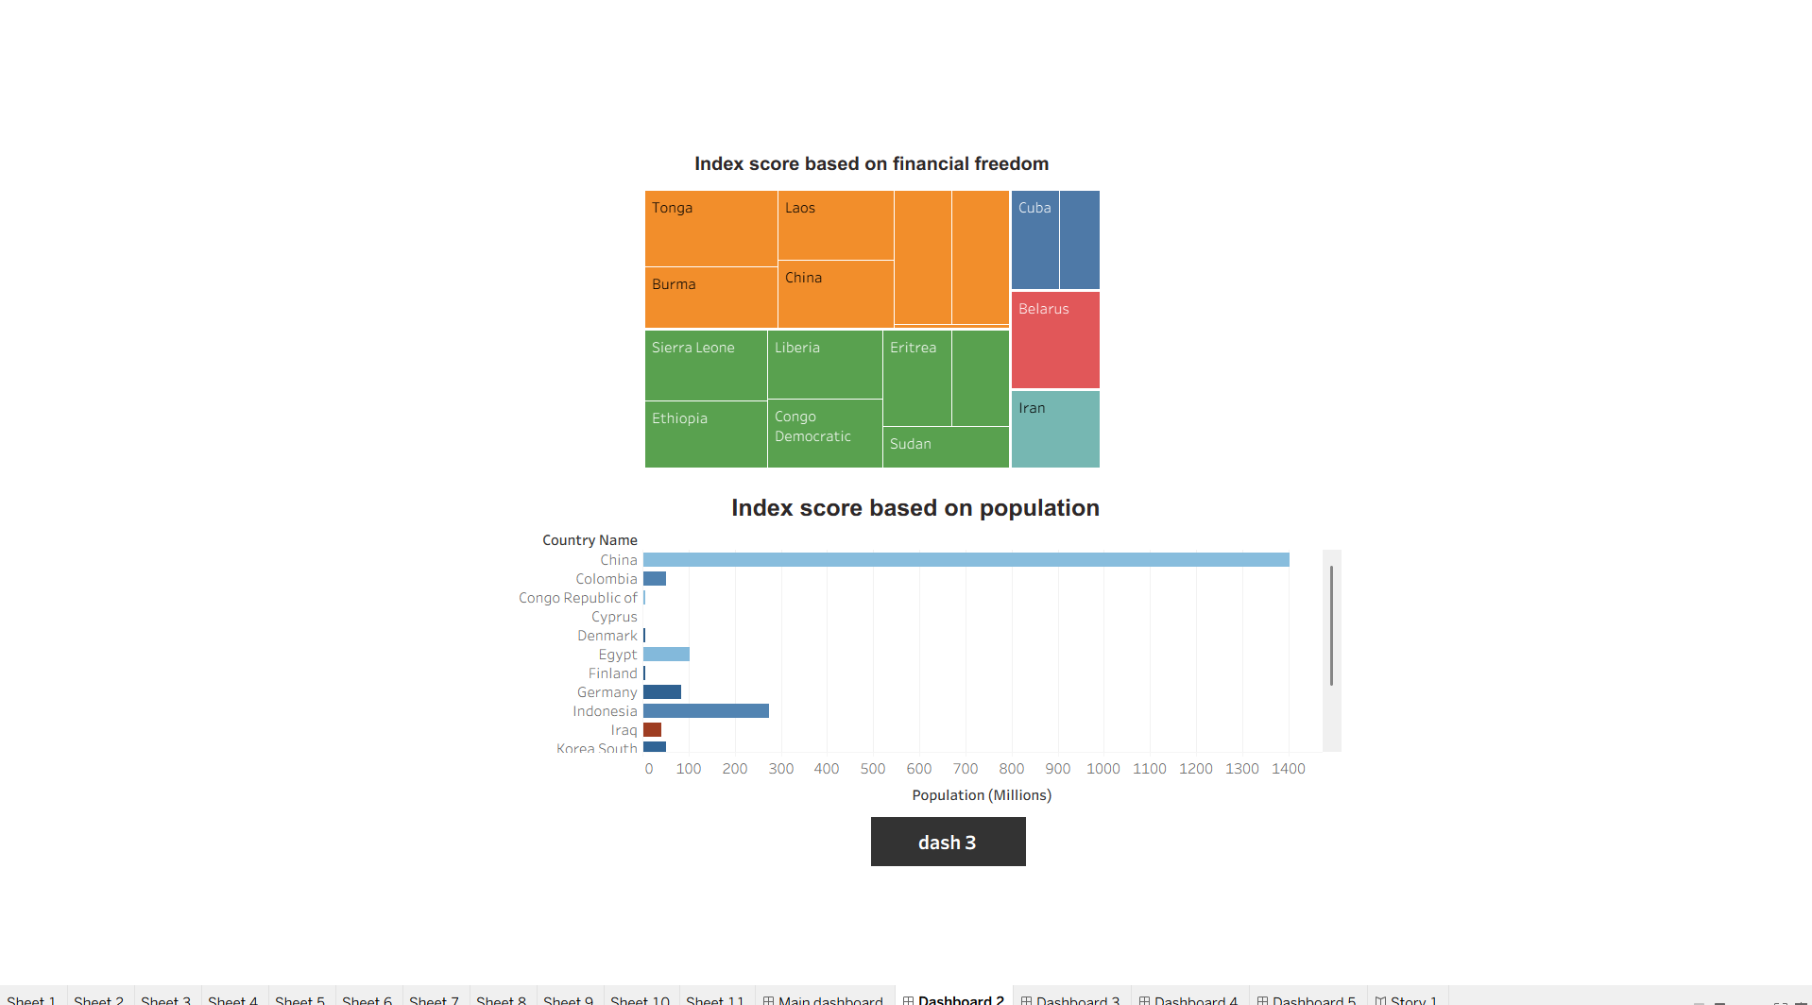

## 

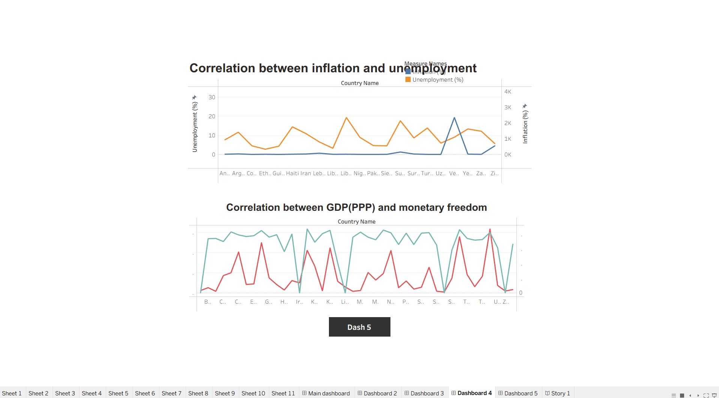

## 

## 8. ADVANTAGES & DISADVANTAGES

Advantages

1. Data-Driven Insights

Empowers users to make informed decisions using real- me, evidence-based economic indicators.

1. Interac ve Visualiza on

User-friendly dashboards allow for filtering by year, country, and economic subindices, making analysis accessible to non-technical users.

1. Mul -Stakeholder U lity

Useful to policymakers, researchers, investors, and students alike, each gaining insights specific to their objec ves.

1. Customizable & Scalable

The modular architecture allows easy integra on of new datasets, indicators, or visualiza on layers.

1. Open-Source & Cost-Efficient

Built using open-source tools like Python, Plotly, and Streamlit, reducing development and deployment costs.

Disadvantages

1. Data Source Dependency

The analysis is limited to the scope and accuracy of available datasets like those from the Heritage Founda on or World Bank.

1. Limited Real-Time Updates

Economic freedom indices are not updated frequently, which may affect relevance for real- me policy decisions.

1. Technical Barriers for Non-Digital Users

Despite being user-friendly, some stakeholders without digital literacy may find the pla orm less accessible.

1. Infrastructure Limita ons

Hos ng and processing large datasets or high user traffic could require scaling the cloud infrastructure, leading to addi onal costs.

9. CONCLUSION:

The project “Measuring the Pulse of Prosperity: An Index of Economic Freedom Analysis” successfully demonstrates the power of data analy cs and visualiza on in transforming sta c economic data into meaningful, ac onable insights. By leveraging open-source tools and interac ve dashboards, the pla orm bridges the gap between complex economic indicators and userfriendly interpreta on.

This solu on empowers policymakers, researchers, and investors to explore global economic trends, iden fy policy gaps, and make evidence-based decisions. The integra on of filtering, correla on analysis, and exportable visualiza ons enhances the usability and adaptability of the system across various domains.

Through this ini a ve, we’ve laid a scalable founda on for deeper explora on of how economic freedom shapes prosperity—enabling smarter governance, more informed investment, and a clearer understanding of global economic landscapes.

## 10. FUTURE SCOPE

* Integra on of Real-Time Economic Indicators

Future versions of the pla orm can incorporate APIs for real- me data (e.g., GDP updates, infla on, employment) to enhance the system’s relevance for ongoing policy and market analysis.

* Expanded Dataset Coverage

The project can be extended to include regional/state-level data, enabling microeconomic analysis within countries and more localized policymaking insights.

* Machine Learning-Based Forecas ng

Implemen ng predic ve models can help forecast future economic freedom scores or prosperity indicators based on historical pa erns and current inputs.

* User Personaliza on and No fica ons

Future itera ons could allow user accounts with saved filters, email alerts for new reports, or policy shi s relevant to selected countries.

# 11. APPENDIX

Dataset Link:



GitHub & Project Demo Link:

Project Demo Link:

https://drive.google.com/file/d/1DVufSewRirJDoB2ShDsv6QrYs6dzjXbn/view?usp=drive_link